Launch an EC2 instance (Linux and Windows) along with a web server. Then, create an EBS volume of 5 GB, attach it to an EC2 machine (Linux and Windows), and take a snapshot. Finally, create an EBS volume using the taken snapshot.

Launch an EC2 instance (Linux and Windows) along with a web server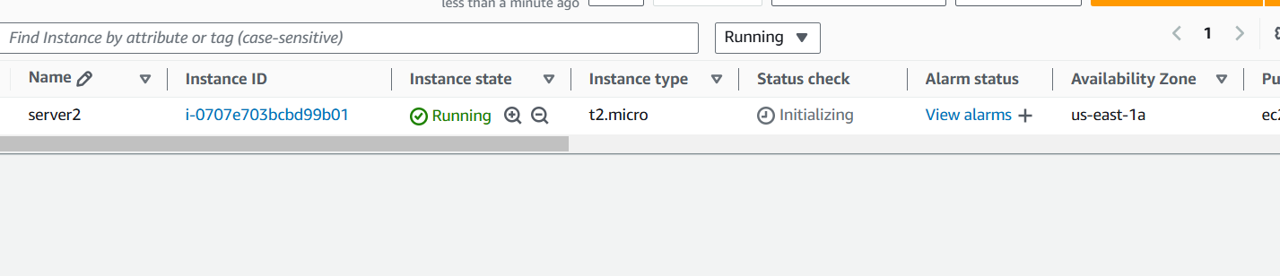

create an EBS volume of 5 GB

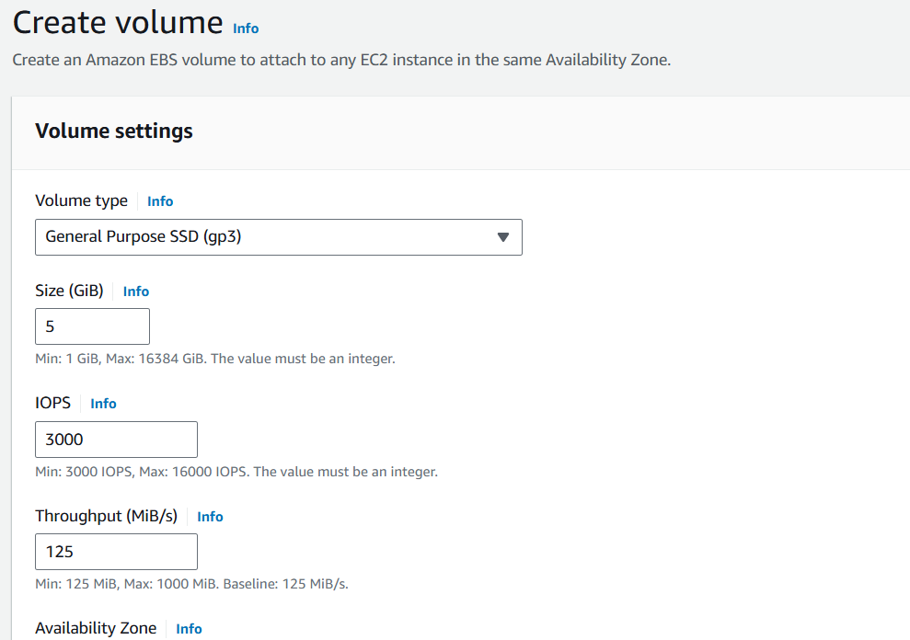

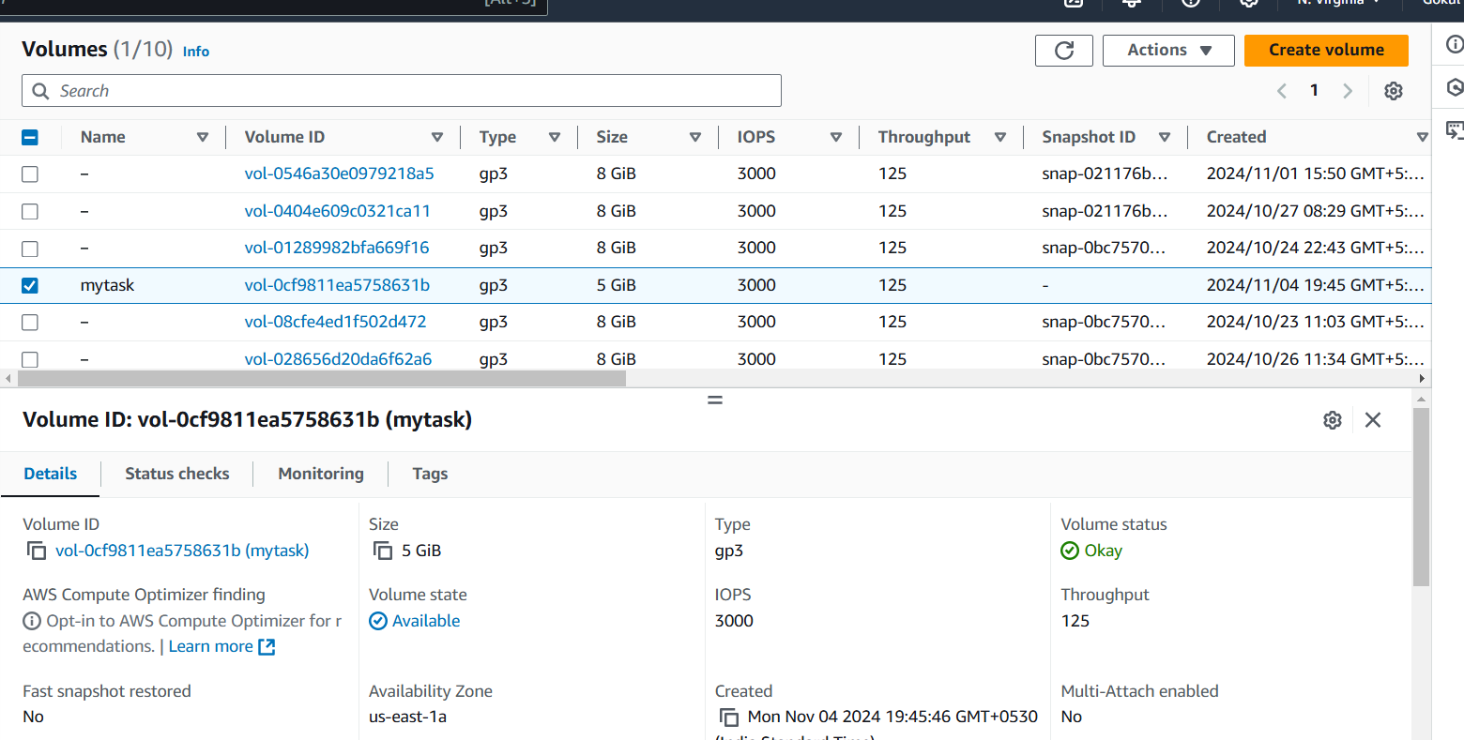

Finally create a volume in EBS

Now attach it to an EC2 machine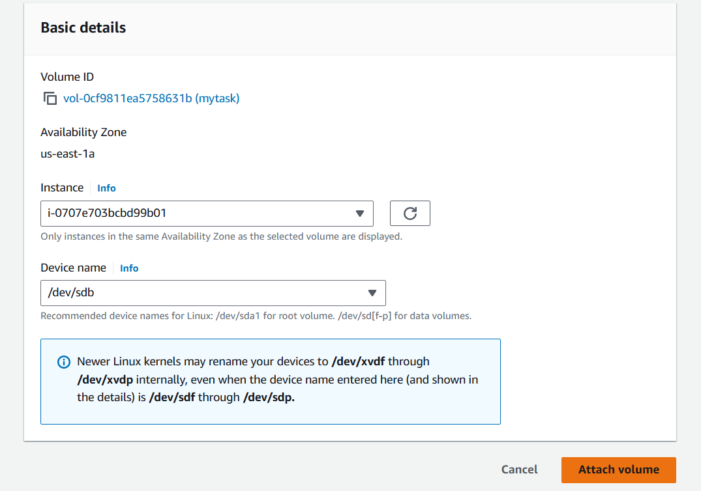

In Ec2 instance select the volume in storage

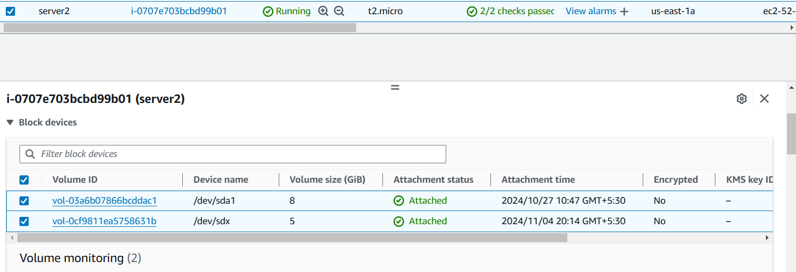

Now volume attached to ec2 instances

